Horizontal Arrangement

Definition
# Source: AI Source: Provided by: [Data Path: Persons Table -> ID Column: 1, Name_En Column: Motasem Essam] -> From: [ChatGPT] on [7/25/2026]
Horizontal Arrangement is a type of composite solid arrangement in which two or more repeated solid components are positioned beside one another along a horizontal direction.
The components may be identical or different in dimensions, and they are generally distributed across a common horizontal level. They may be directly connected through shared faces or curved contact regions, partially joined, or separated by gaps.
When components are joined, their contact regions become hidden internal interfaces.

Simple Definition
# Source: AI Source: Provided by: [Data Path: Persons Table -> ID Column: 1, Name_En Column: Motasem Essam] -> From: [ChatGPT] on [7/25/2026]
A composite solid arrangement in which repeated solid components are positioned beside one another horizontally.

Geometric Representation
# Source: AI Source: Provided by: [Data Path: Persons Table -> ID Column: 1, Name_En Column: Motasem Essam] -> From: [ChatGPT] on [7/25/2026]
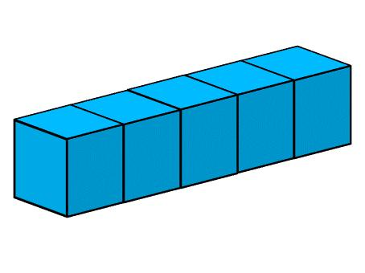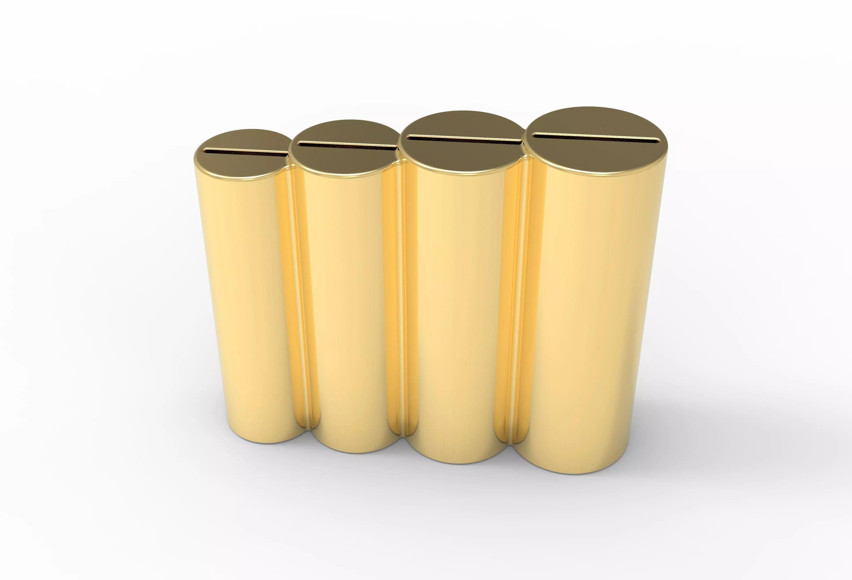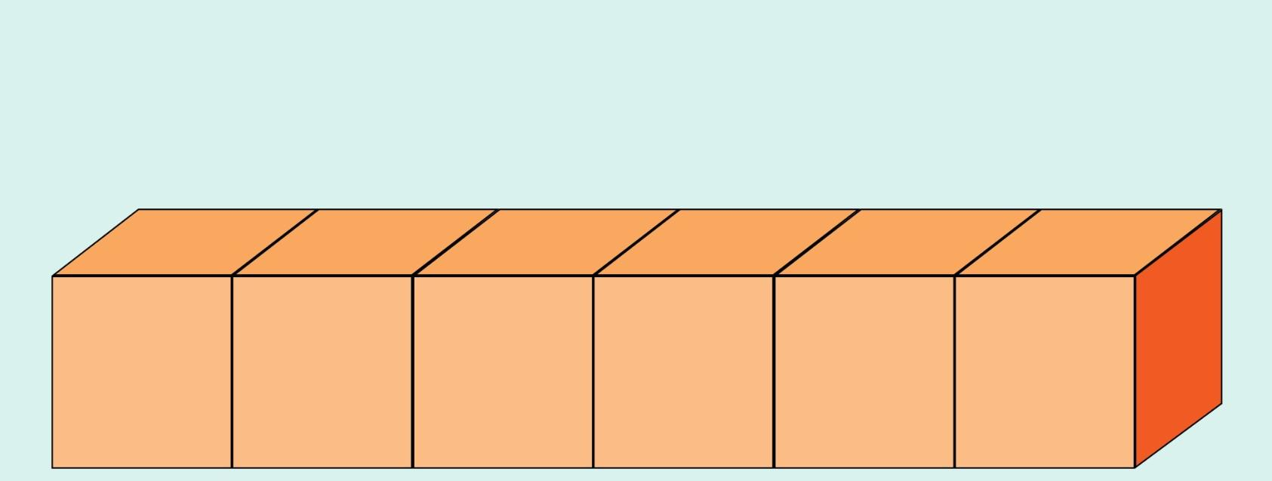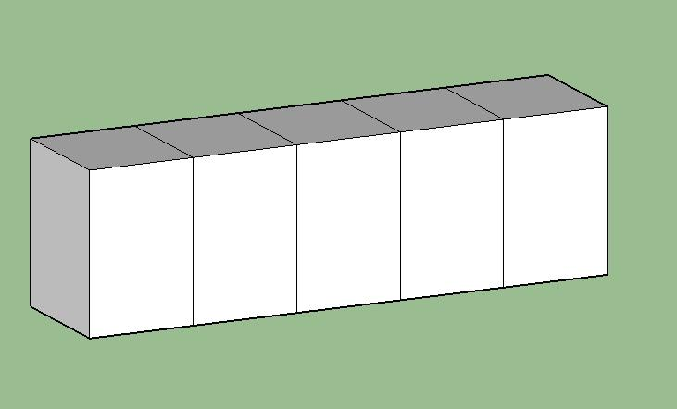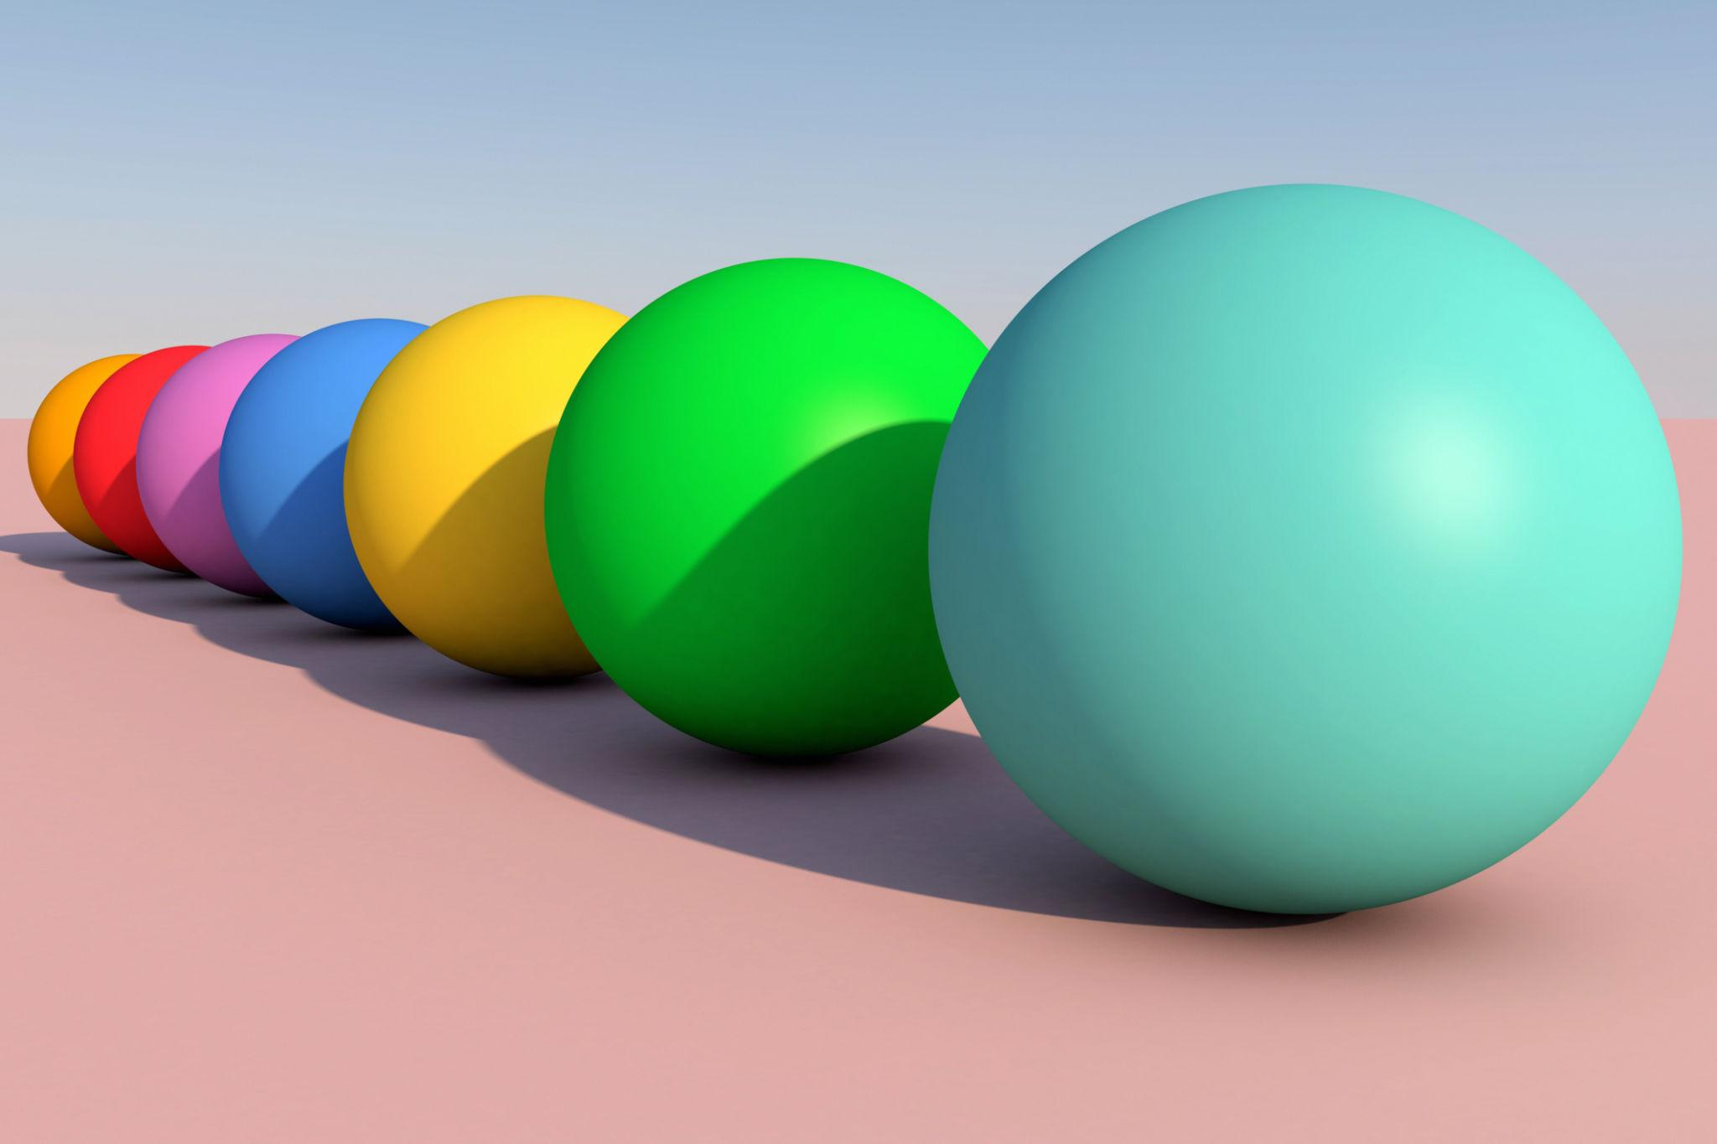
A horizontal arrangement has three main characteristics:
- Horizontal positioning: Components are distributed along a horizontal direction.
- Side-by-side placement: Components occupy neighboring positions.
- Repeated components: The same solid shape or a repeating combination of solid shapes is used.

Main Classification
# Source: AI Source: Provided by: [Data Path: Persons Table -> ID Column: 1, Name_En Column: Motasem Essam] -> From: [ChatGPT] on [7/25/2026]
Horizontal arrangements can be classified according to the geometric shape of their repeated components.

Cube-Based Horizontal Arrangement
# Source: AI Source: Provided by: [Data Path: Persons Table -> ID Column: 1, Name_En Column: Motasem Essam] -> From: [ChatGPT] on [7/25/2026]
A composite solid formed by positioning two or more cubes beside one another along a horizontal direction.
Characteristics:
- Components are cubes.
- They may have equal or different side lengths.
- Equal-sized cubes joined face-to-face form a wider rectangular prism.

Rectangular Prism-Based Horizontal Arrangement
# Source: AI Source: Provided by: [Data Path: Persons Table -> ID Column: 1, Name_En Column: Motasem Essam] -> From: [ChatGPT] on [7/25/2026]
A composite solid formed by positioning two or more rectangular prisms beside one another.
Characteristics:
- Components have rectangular prism shapes.
- Their lengths, widths, and heights may be identical or different.
- The arrangement may form a wide or extended rectangular structure.

Cylinder-Based Horizontal Arrangement
# Source: AI Source: Provided by: [Data Path: Persons Table -> ID Column: 1, Name_En Column: Motasem Essam] -> From: [ChatGPT] on [7/25/2026]
A composite solid arrangement formed by positioning two or more cylinders beside one another along a horizontal direction.
Characteristics:
- Cylinders may have parallel central axes.
- Their radii and heights may be equal or different.
- They may touch along curved surfaces or be connected through supporting components.
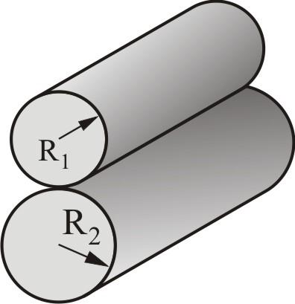

Cone-Based Horizontal Arrangement
# Source: AI Source: Provided by: [Data Path: Persons Table -> ID Column: 1, Name_En Column: Motasem Essam] -> From: [ChatGPT] on [7/25/2026]
A composite solid arrangement formed by positioning two or more cones beside one another horizontally.
Possible configurations include:
- Cones with parallel central axes.
- Cones with their bases facing the same direction.
- Cones with alternating orientations.
- Cones attached to a shared flat supporting component.


Sphere-Based Horizontal Arrangement
# Source: AI Source: Provided by: [Data Path: Persons Table -> ID Column: 1, Name_En Column: Motasem Essam] -> From: [ChatGPT] on [7/25/2026]
A horizontal arrangement in which two or more spheres are positioned beside one another.
Characteristics:
- Sphere centers may lie along a common horizontal line.
- Spheres may have equal or different radii.
- They may touch at individual points or remain separated by gaps.
Important: Externally tangent spheres touch at a point, not across a surface. Therefore, they do not have a positive-area joining interface.
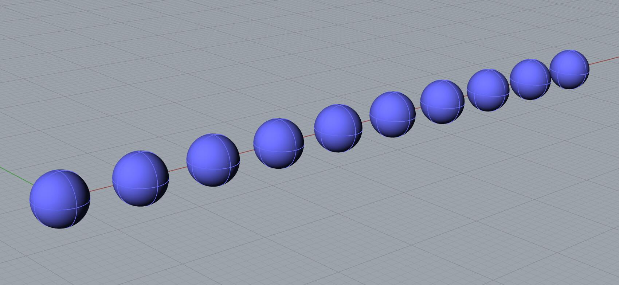

Hemisphere-Based Horizontal Arrangement
# Source: AI Source: Provided by: [Data Path: Persons Table -> ID Column: 1, Name_En Column: Motasem Essam] -> From: [ChatGPT] on [7/25/2026]
A composite arrangement formed by positioning two or more hemispheres beside one another horizontally.
Possible configurations include:
- Hemispheres with their flat circular bases facing the same direction.
- Hemispheres with alternating curved-surface orientations.
- Hemispheres connected through a common flat supporting component.
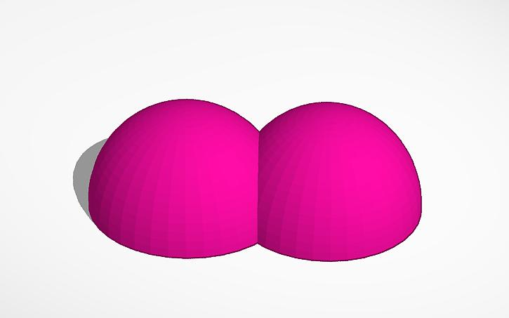

Mixed-Shape Horizontal Arrangement
# Source: AI Source: Provided by: [Data Path: Persons Table -> ID Column: 1, Name_En Column: Motasem Essam] -> From: [ChatGPT] on [7/25/2026]
A horizontal arrangement containing repeated components from two or more different geometric solid types.
Examples:
- Alternating cylinders and cones.
- Rectangular prisms placed beside hemispherical components.
- Cylinders positioned beside spherical components.
- Repeated sequences of prisms, cylinders, cones, and hemispheres.
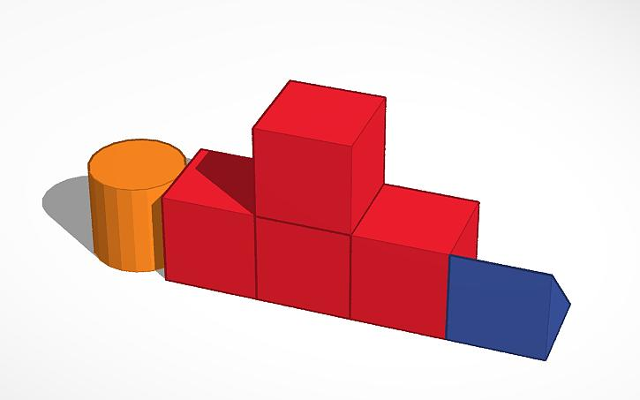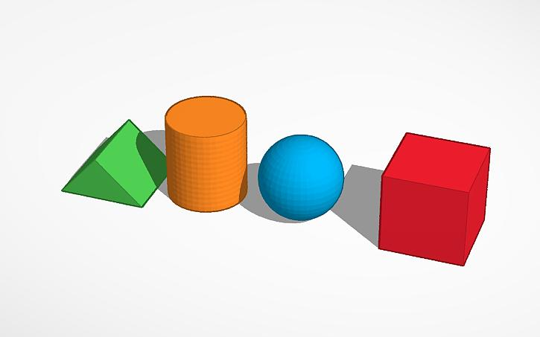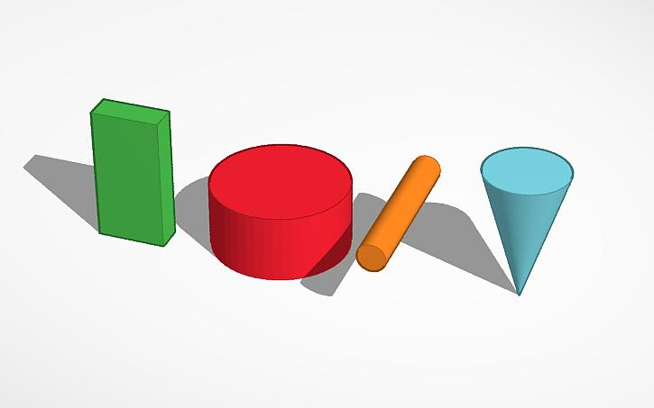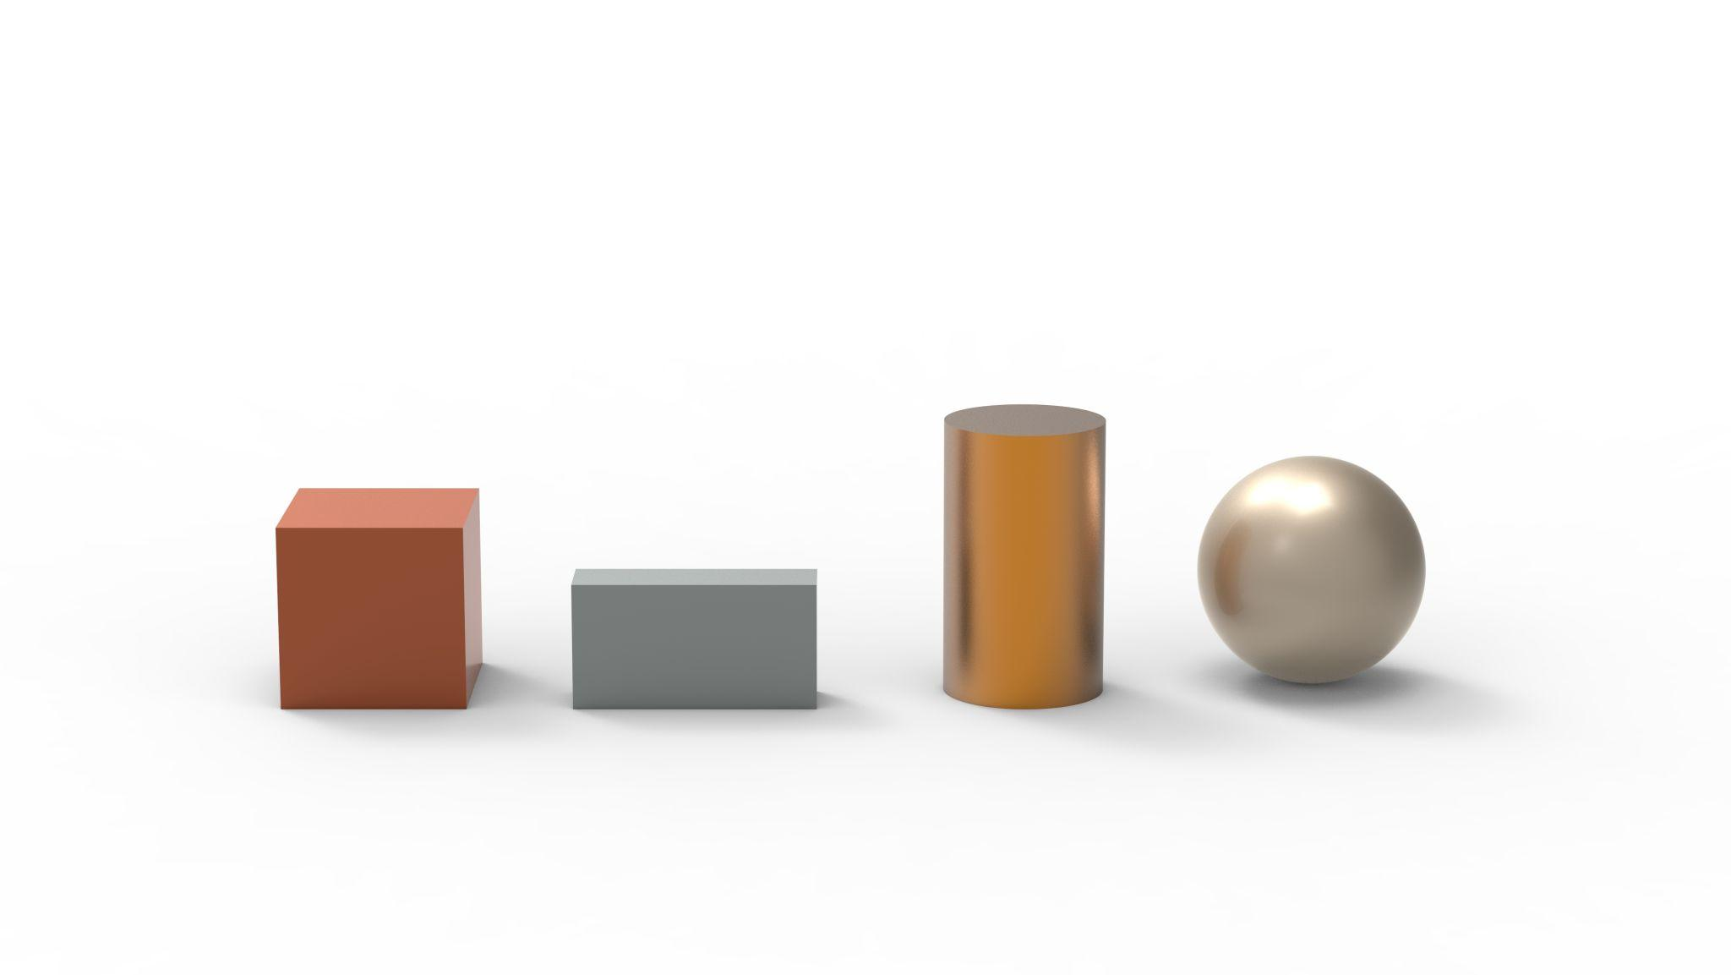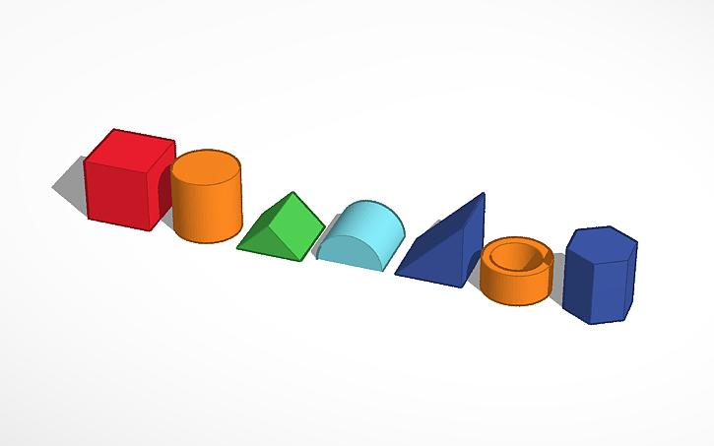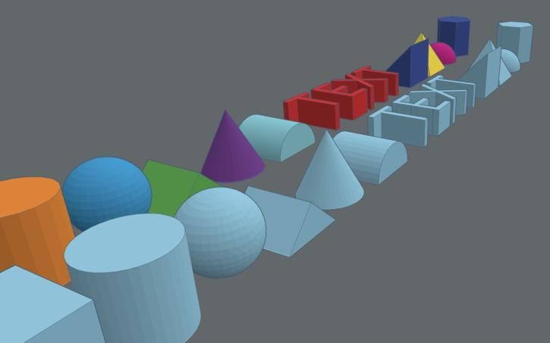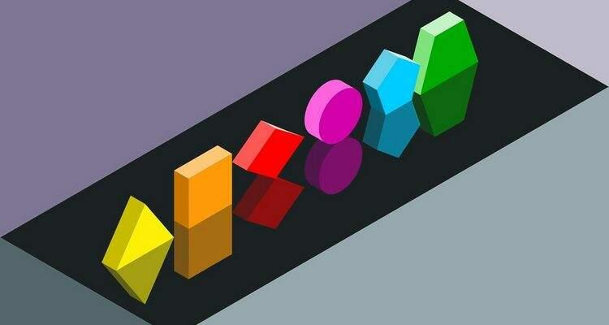

Classification by Horizontal Alignment

Centered Horizontal Arrangement
# Source: AI Source: Provided by: [Data Path: Persons Table -> ID Column: 1, Name_En Column: Motasem Essam] -> From: [ChatGPT] on [7/25/2026]
Components are positioned side by side while their corresponding centers or central axes follow a common horizontal alignment.
Examples:
- Cylinders with parallel central axes.
- Equal-sized cubes arranged in a straight horizontal row.
- Spheres with centers along a common horizontal line.
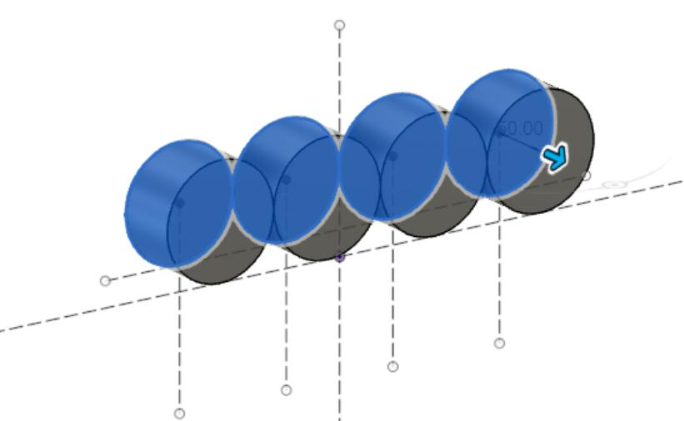

Offset Horizontal Arrangement
# Source: AI Source: Provided by: [Data Path: Persons Table -> ID Column: 1, Name_En Column: Motasem Essam] -> From: [ChatGPT] on [7/25/2026]
Each successive component is shifted vertically or in another transverse direction relative to its neighboring component while the overall arrangement extends horizontally.
Examples:
- Staggered rows of cubes.
- Offset rectangular prisms.
- Cylinders arranged in a horizontally extended stepped pattern.
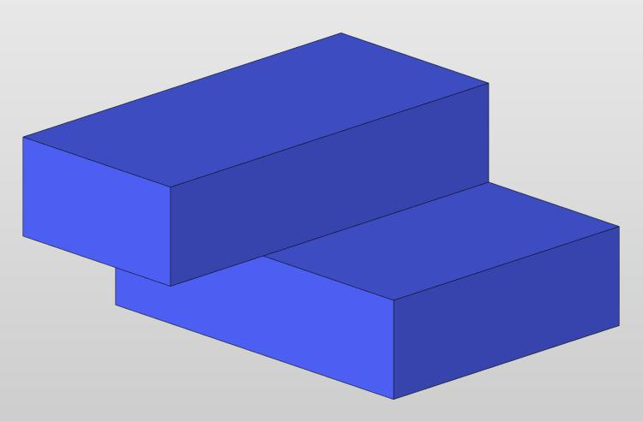

Stepped Horizontal Arrangement
# Source: AI Source: Provided by: [Data Path: Persons Table -> ID Column: 1, Name_En Column: Motasem Essam] -> From: [ChatGPT] on [7/25/2026]
Components are positioned horizontally with changing dimensions or vertical positions, creating a stepped external profile.
Examples:
- Blocks with progressively increasing heights.
- Cylinders with different radii arranged horizontally.
- Alternating large and small rectangular prisms.
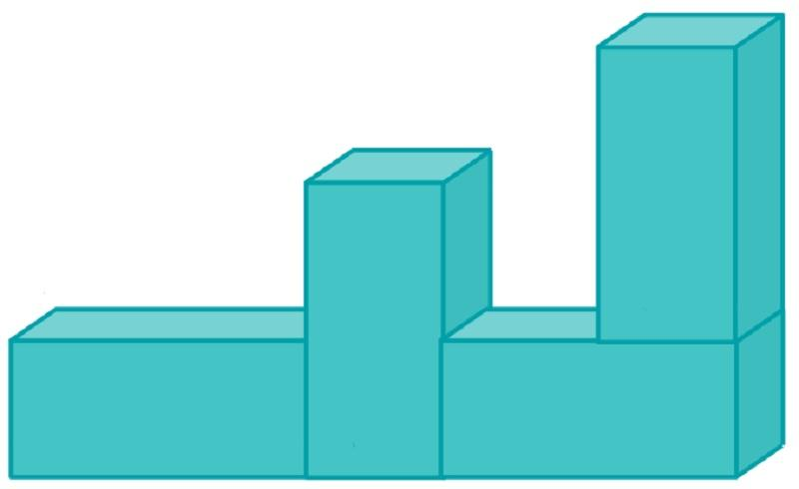

Classification by Contact Between Components

Direct Horizontal Arrangement
# Source: AI Source: Provided by: [Data Path: Persons Table -> ID Column: 1, Name_En Column: Motasem Essam] -> From: [ChatGPT] on [7/25/2026]
Components are connected directly through shared contact regions.
Examples:
- Cubes joined through vertical square faces.
- Rectangular prisms joined side-to-side.
- Components attached through matching planar faces.
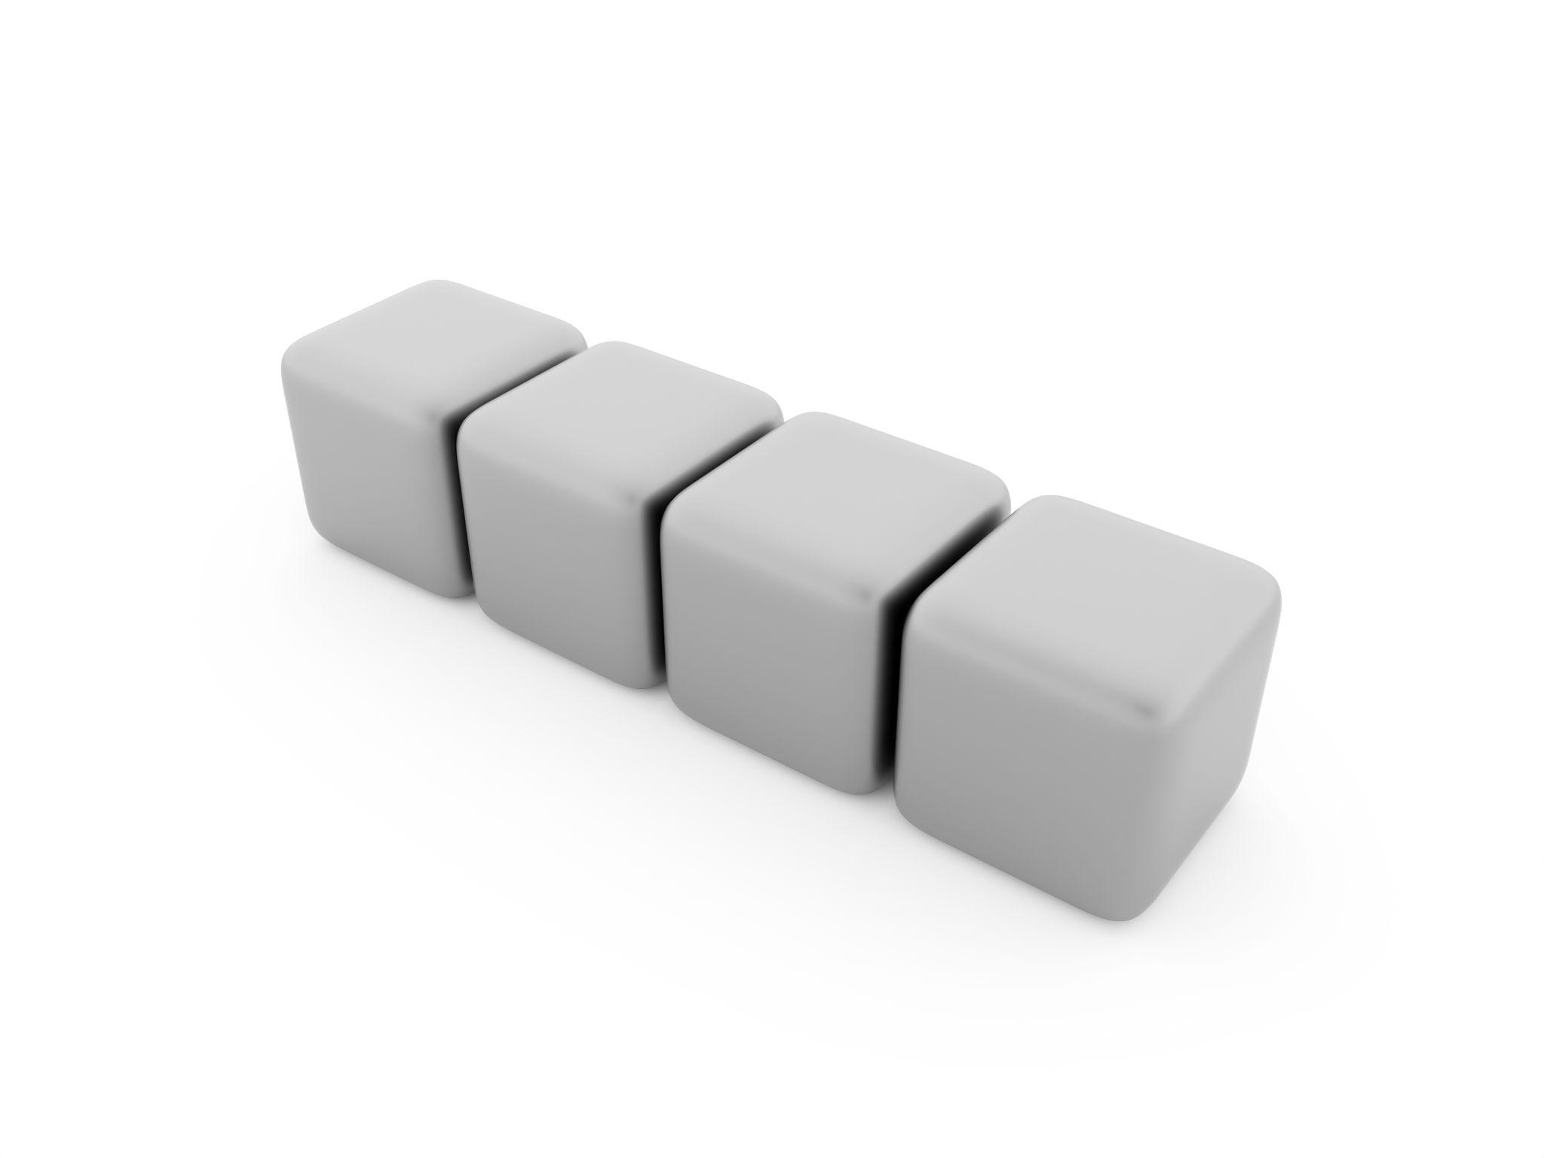

Spaced Horizontal Arrangement
# Source: AI Source: Provided by: [Data Path: Persons Table -> ID Column: 1, Name_En Column: Motasem Essam] -> From: [ChatGPT] on [7/25/2026]
Components are positioned beside one another with gaps between consecutive components.
Examples:
- Separate spheres arranged in a horizontal row.
- Cylinders positioned with equal horizontal spacing.
- Repeated cubes separated by small gaps.
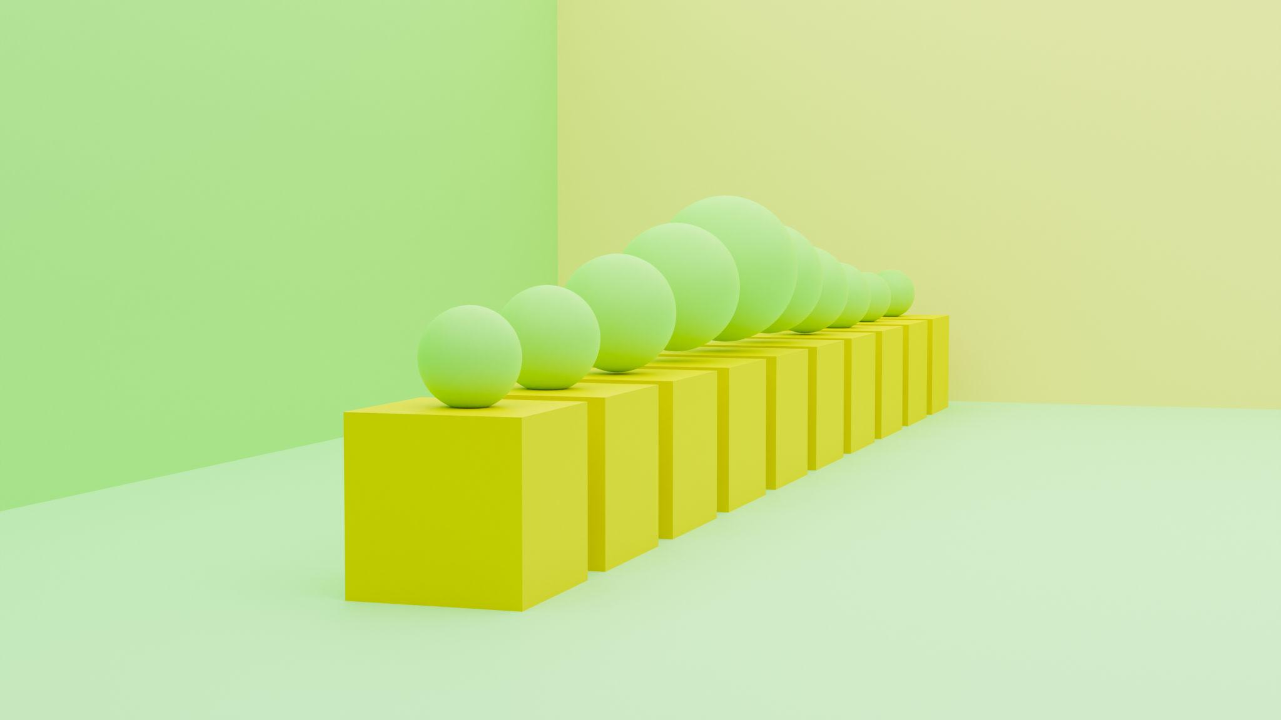

Partially Joined Horizontal Arrangement
# Source: AI Source: Provided by: [Data Path: Persons Table -> ID Column: 1, Name_En Column: Motasem Essam] -> From: [ChatGPT] on [7/25/2026]
Components are connected through only part of their possible contact regions.
Examples:
- Two cylinders connected through partial curved contact.
- A smaller prism attached to part of a larger prism's side face.
- Components connected through partial planar interfaces.
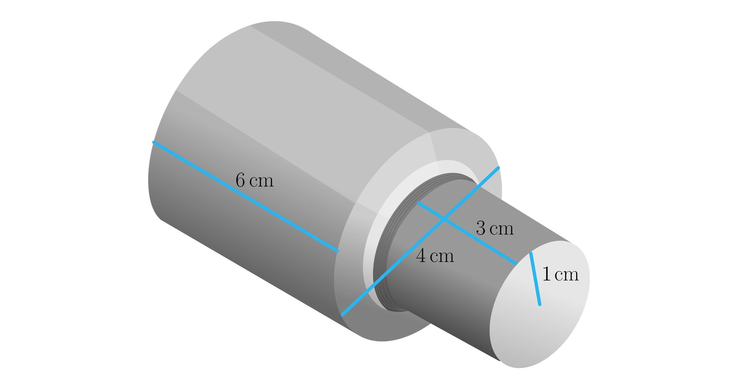

Classification by Component Dimensions
# Source: AI Source: Provided by: [Data Path: Persons Table -> ID Column: 1, Name_En Column: Motasem Essam] -> From: [ChatGPT] on [7/25/2026]
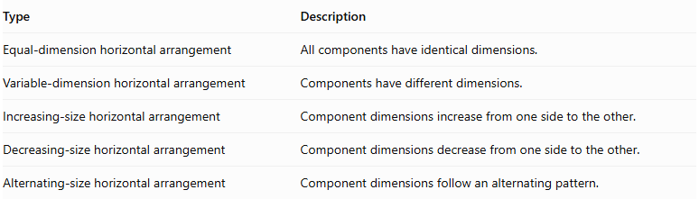
Type | Description
Equal-dimension horizontal arrangement | All components have identical dimensions.
Variable-dimension horizontal arrangement | Components have different dimensions.
Increasing-size horizontal arrangement | Component dimensions increase from one side to the other.
Decreasing-size horizontal arrangement | Component dimensions decrease from one side to the other.
Alternating-size horizontal arrangement | Component dimensions follow an alternating pattern.
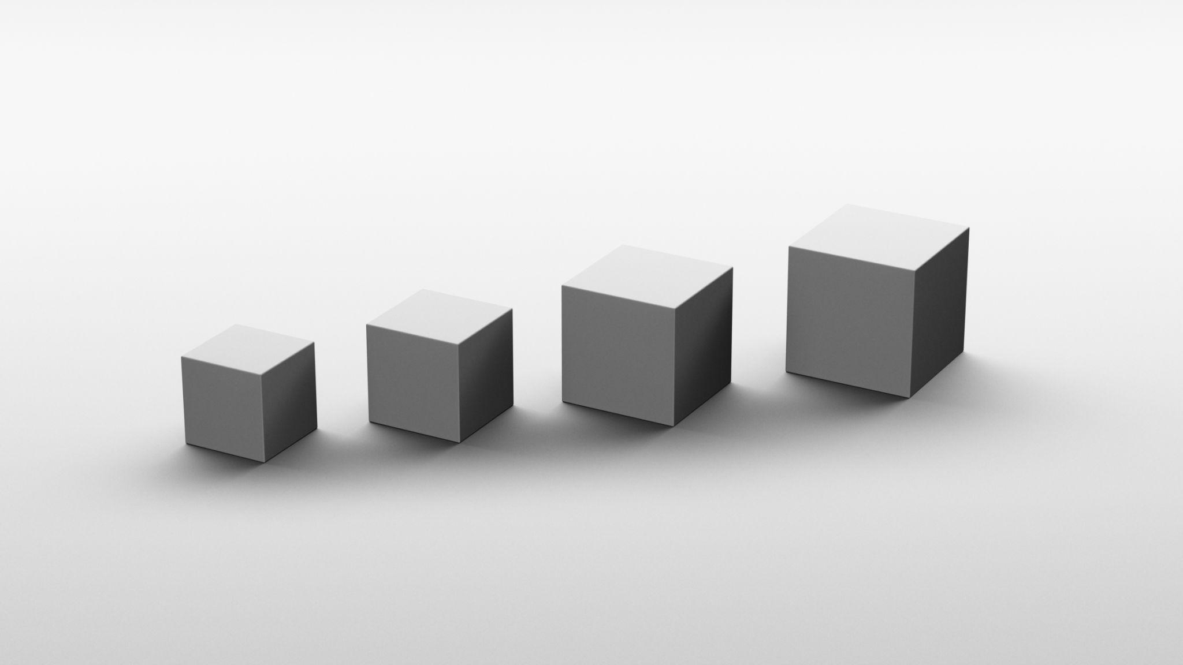

Mathematical Properties and Formulas

Total Volume
# Source: AI Source: Provided by: [Data Path: Persons Table -> ID Column: 1, Name_En Column: Motasem Essam] -> From: [ChatGPT] on [7/25/2026]
For components arranged without overlapping interiors:
$$V_{total}=\sum_{i=1}^{n}{V_{i}}$$
For identical components:
$$\boxed{V_{total}={nV}_{component}}$$
Common volume formulas:
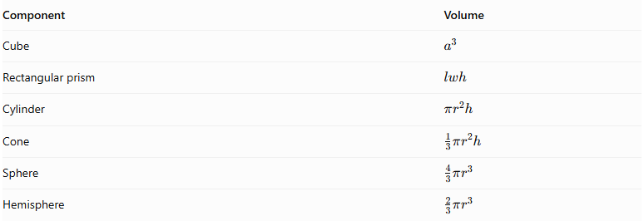
Component | Volume
Cube | $$a^{3}$$
Rectangular prism | $$lwh$$
Cylinder | $$πr^{2}h$$
Cone | $$\frac{1}{3}πr^{2}h$$
Sphere | $$\frac{4}{3}πr^{3}$$
Hemisphere | $$\frac{2}{3}πr^{3}$$

Overall Horizontal Length
# Source: AI Source: Provided by: [Data Path: Persons Table -> ID Column: 1, Name_En Column: Motasem Essam] -> From: [ChatGPT] on [7/25/2026]
When components are positioned consecutively along a horizontal direction without gaps or overlaps:
$$\boxed{L_{total}=\sum_{i=1}^{n}{l_{i}}}$$
For identical components:
$$\boxed{L_{total}=nl}$$
If equal horizontal gaps of length $g$ separate the components:
$$\boxed{L_{total}=nl+(n-1)g}$$
Where:
- $n$ = number of components.
- $l$ = horizontal length of each identical component.
- $g$ = gap between consecutive components.

External Surface Area
# Source: AI Source: Provided by: [Data Path: Persons Table -> ID Column: 1, Name_En Column: Motasem Essam] -> From: [ChatGPT] on [7/25/2026]
For directly joined components:
$${SA}_{external}=\sum{{SA}_{individual}}-\sum{A_{hidden interfaces}}$$
For complete matching planar joining faces:
$$\boxed{{SA}_{external}=\sum{{SA}_{individual}}-2\sum{A_{joining}}}$$
For partial contact, only the actual hidden contact regions are excluded.
For spaced components, no joining surfaces are hidden, so the total surface area is the sum of their individual surface areas.

Worked Examples

Example 1: Horizontal Arrangement of Identical Cubes
# Source: AI Source: Provided by: [Data Path: Persons Table -> ID Column: 1, Name_En Column: Motasem Essam] -> From: [ChatGPT] on [7/25/2026]
Four identical cubes, each with a side length of $4 cm$, are joined horizontally, one beside another.
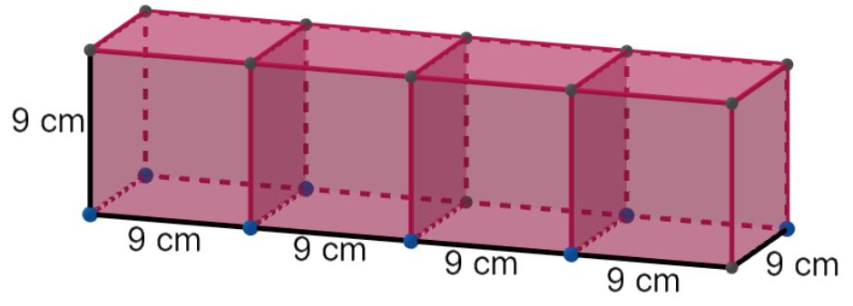
Step 1: Calculate the volume of one cube.
$$V_{1}=a^{3}$$
$$V_{1}=4^{3}=64{ cm}^{3}$$
Step 2: Calculate the total volume.
$$V_{total}=4×64$$
$$\boxed{V_{total}=256{ cm}^{3}}$$
Step 3: Calculate the overall horizontal length.
$$L=4×4$$
$$\boxed{L=16 cm}$$
Step 4: Calculate the external surface area.
The four cubes form a rectangular prism with dimensions:
$$16×4×4$$
$$SA=2(lw+lh+wh)$$
$$=2(16×4+16×4+4×4)$$
$$=2(64+64+16)$$
$$\boxed{SA=288{ cm}^{2}}$$

Example 2: Horizontal Arrangement of Three Rectangular Prisms
# Source: AI Source: Provided by: [Data Path: Persons Table -> ID Column: 1, Name_En Column: Motasem Essam] -> From: [ChatGPT] on [7/25/2026]
Three rectangular prisms are joined horizontally side by side.
Their dimensions are:
- Prism 1: $4×3×5 cm$.
- Prism 2: $4×3×5 cm$.
- Prism 3: $4×3×5 cm$.
Assume they are joined through their matching $3×5$ faces.
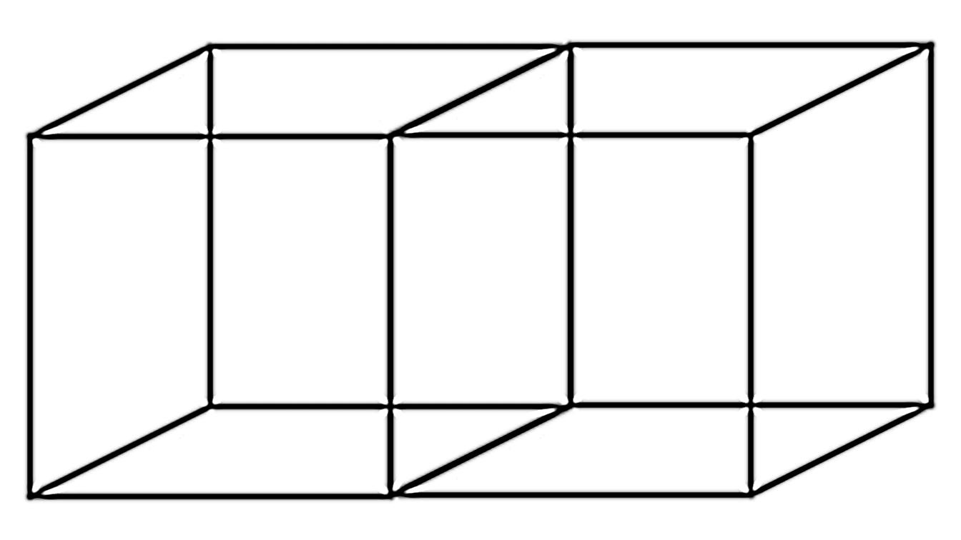
Step 1: Calculate the volume of one prism.
$$V_{1}=4×3×5=60{ cm}^{3}$$
Step 2: Calculate the total volume.
$$V_{total}=3×60$$
$$\boxed{V_{total}=180{ cm}^{3}}$$
Step 3: Calculate the overall horizontal length.
$$L=3×4$$
$$\boxed{L=12 cm}$$
Step 4: Calculate the external surface area.
The resulting solid is a rectangular prism with dimensions:
$$12×3×5$$
$$SA=2(lw+lh+wh)$$
$$=2(12×3+12×5+3×5)$$
$$=2(36+60+15)$$
$$\boxed{SA=222{ cm}^{2}}$$

Important Characteristics
# Source: AI Source: Provided by: [Data Path: Persons Table -> ID Column: 1, Name_En Column: Motasem Essam] -> From: [ChatGPT] on [7/25/2026]
- Horizontal orientation: Components extend along a horizontal direction.
- Side-by-side positioning: Components occupy neighboring positions.
- Repeated geometry: The same solid type or a repeating pattern is used.
- Variable dimensions: Components may have equal or different dimensions.
- Alignment flexibility: Components may be centered, offset, or arranged in stepped patterns.
- Contact flexibility: Components may be directly joined, partially joined, or separated by gaps.
- Length dependency: Overall horizontal length depends on component dimensions and spacing.
- Surface-area dependency: External surface area depends on the exposed and hidden regions of each component.

Comparison with Other Component Arrangements
# Source: AI Source: Provided by: [Data Path: Persons Table -> ID Column: 1, Name_En Column: Motasem Essam] -> From: [ChatGPT] on [7/25/2026]
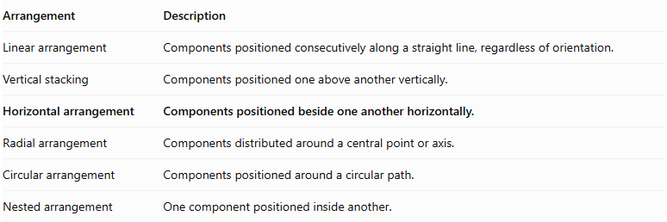
Arrangement | Description
Linear arrangement | Components positioned consecutively along a straight line, regardless of orientation.
Vertical stacking | Components positioned one above another vertically.
Horizontal arrangement | Components positioned beside one another horizontally.
Radial arrangement | Components distributed around a central point or axis.
Circular arrangement | Components positioned around a circular path.
Nested arrangement | One component positioned inside another.

Applications
# Source: AI Source: Provided by: [Data Path: Persons Table -> ID Column: 1, Name_En Column: Motasem Essam] -> From: [ChatGPT] on [7/25/2026]
- Horizontal structural beams and modular building blocks.
- Side-by-side storage tanks.
- Parallel cylindrical pipes and mechanical rollers.
- Repeated industrial components arranged across a horizontal platform.
- Decorative geometric structures.
- Modular furniture and construction assemblies.

Key Points
# Source: AI Source: Provided by: [Data Path: Persons Table -> ID Column: 1, Name_En Column: Motasem Essam] -> From: [ChatGPT] on [7/25/2026]
- Horizontal arrangement places repeated components beside one another.
- Components may be cubes, rectangular prisms, cylinders, cones, spheres, hemispheres, or mixed shapes.
- Arrangements may be centered, offset, or stepped.
- Components may be directly joined, partially joined, or separated by gaps.
- Total volume is the sum of component volumes when there is no overlap.
- Overall horizontal length includes component lengths and any gaps.
- External surface area excludes hidden joining regions.

Conclusion
# Source: AI Source: Provided by: [Data Path: Persons Table -> ID Column: 1, Name_En Column: Motasem Essam] -> From: [ChatGPT] on [7/25/2026]
Horizontal Arrangement is a classification of composite solids in which repeated components are positioned beside one another along a horizontal direction. The components may have identical or different dimensions and can form centered, offset, or stepped structures. Their overall geometry depends on component dimensions, horizontal alignment, spacing, and contact regions.

